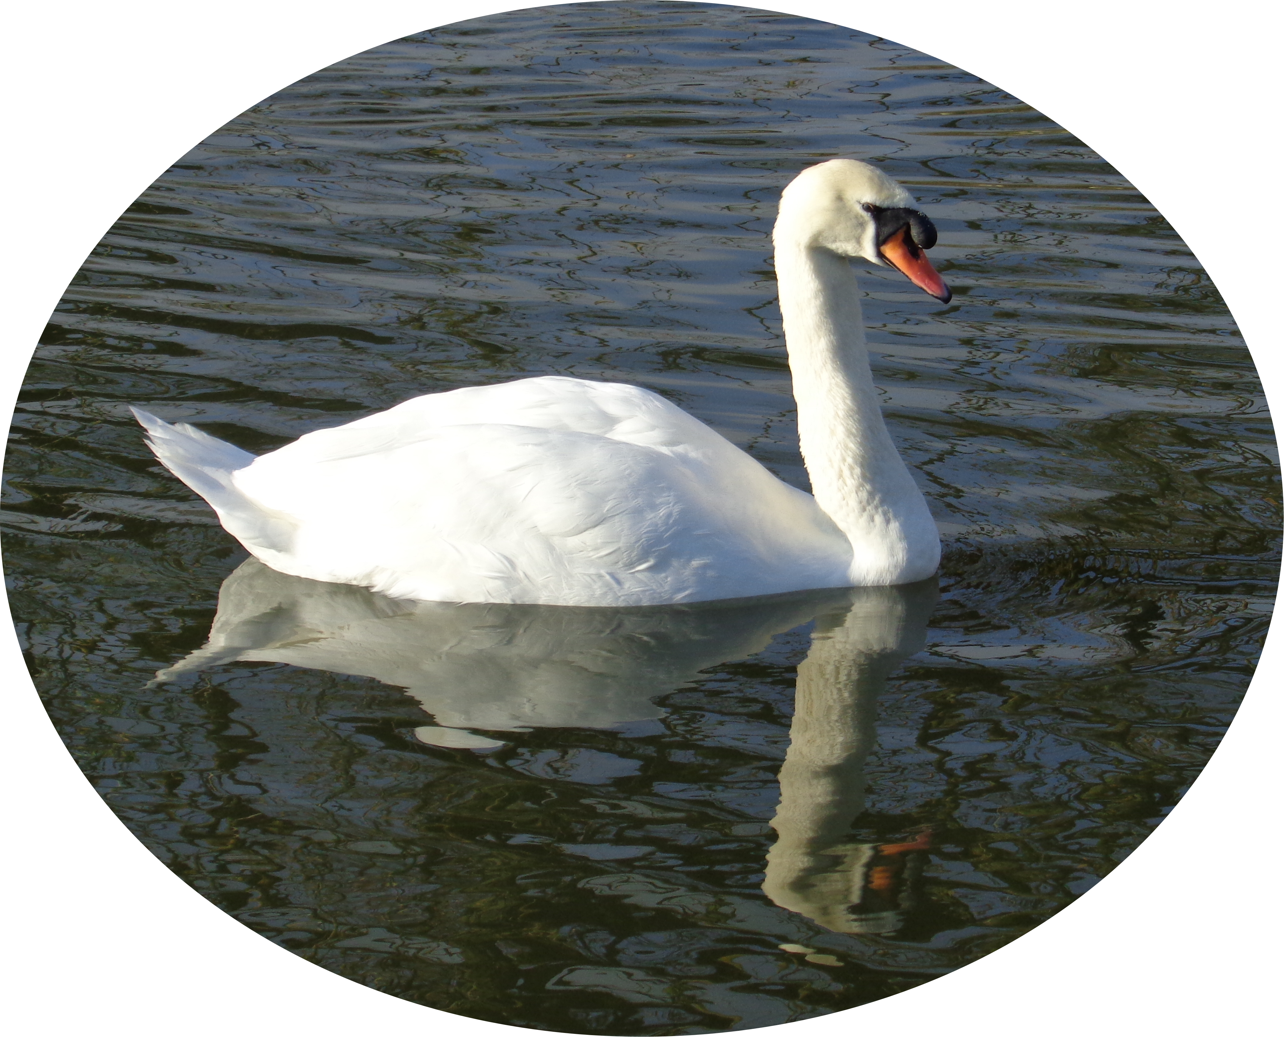PAGAN TRANSITIONS™
Copyright 2003-2018

ADVANCE FUNERAL DIRECTIVE FOR PAGANS

Thinking of your own funeral may seem strange so why make an Advance Funeral Directive?

By taking a few moments now, you will save your loved ones the burden of uncertainty at the time of your passing over. This Directive will give them the information needed to arrange your funeral, if possible, in accordance with your wishes. This is especially important if they are not of the same religion because they may not know what religious practices are required for a Pagan funeral.

Writing an Advance Funeral Directive enables you to have a funeral that reflects your life, your beliefs and an opportunity to say any final words to your family and friends. This document will give you some control over your funeral, so that last minute requests don’t have to be made at the “crisis” time of death.

It is important to note that funeral wishes, whether in a Will or an Advance Funeral Directive are not legally binding after death.

Therefore, you should discuss your wishes with the person who will be responsible for arranging your funeral.

Executors: If your partner or spouse have not been appointed as your executor in your Will, control of the funeral arrangements may fall to the parents and the partner’s wishes could be ignored.

Bereavement: Family and friends will be affected by your passing over, and they will be asked to make decisions during that crucial first week or two about the funeral arrangements. If they know what you wanted then it eases the burden on them and will aid in their bereavement process because they know they have carried out your wishes to the best of their abilities.

You can price various funeral options and split the costs into three parts:

- “disbursements” - the sums usually paid by the funeral director on your behalf to doctors (for cremation), the cemetery or crematorium and the minister. Cemetery and crematorium staff can tell you precisely what these charges are in the local area.

- cost of the funeral arrangements made by the funeral directors. These include the cost of collecting, handling and retention of the body, embalming, the coffin, viewing the body, the hearse and cars, and all the professional arrangements.

- cost of the funeral service made by the Funeral Celebrant. These may include the cost of writing the eulogy (if required), conducting the service, printing the Order of Service, flowers etc.

If possible, obtain three quotes from funeral directors. To get a proper comparison ensure you submit the same details to each funeral director.

Note: Unless you are pre-purchasing a funeral plan then remember that any quoted cost may have risen by the time of your death.

SAFE STORAGE: Keep this document in an agreed place so that the person arranging your funeral can find it. DON’T seal it with your Will, if you have one. This is important because sometimes Wills are read after the funeral has taken place and it will then be too late for this document to have any use.

When completing this document, you can amend it as you wish, add pages or delete anything that isn’t relevant for your needs. You can also photocopy this document and give to your family/friends in advance. Don’t worry if you can’t fill it in completely, just do the best you can.

If you are completing this form by hand and some of the questions below do not apply, just put a line through them.

If you are completing this form on your computer, then I suggest you keep the original document intact in case you want to refer to it later. Create a copy and add/delete as required.

Details for the funeral of

Full Name ......................................…………………………

Address ..............................................................................................

………………………………………………………………

Postcode …………….

PRELIMINARY DETAILS

1 | I have /have not written a Will.  If there is a Will, please treat this document as expanding on the wishes expressed in that Will, with the Will taking legal precedent if relevant.  Location of Will
2 | My next of kin is:  Address:  Post Code_________________ Tel. No: __________________________
3 | If different from the above, the person arranging the funeral will be:  Address:  Post Code_________________ Tel. No: __________________________  If you have a Will, and this person is not the executor, then any executor must agree to the arrangements in this document.  If you make your bank, or even a Will Writer, as your executor, charges at perhaps 4% of the estate, can prove very expensive!
4 | Do you wish to donate your body to medical science?  If YES, this must be arranged before you die. It should be noted that as this will no longer be a conventional funeral, most of this form will not apply.  Please note that confirmation of acceptance must be obtained prior to your funeral. Not all bodies are deemed suitable for donation. | YES / NO
5 | Have you completed a “Living Will”  A Living Will is an advanced decision which allows you to express your wishes to refuse medical treatment in future. An advance decision would become relevant if there came a time when you were unable to make or communicate your own decisions and allows you to refuse treatment, even if this might lead to your death. An advance decision is legally binding which means that those caring for you must follow your instructions.  However, it will only be used if you lose the capacity to make or communicate decisions about your treatment. | YES / NO
6 | Is the person arranging your funeral going to use a funeral director?  If YES, do you have a particular funeral director in mind?  Funeral Director’s name and address:  _______________________________________________________  _______________________________________________________  _______________________________________________________  Otherwise, it will be assumed the person arranging your funeral can make the choice.  If you put NO, please enter the name of the person who will arrange your funeral without a funeral director. Unless they are experienced, i.e. Funeral Celebrant, then they may need to take advice from cemetery or crematorium staff to ensure they can handle the arrangements. | YES / NO
7 | Do you have a pre-paid Funeral Plan?  If YES, please enter the name of the nominated funeral director under the Plan.  _________________________________________________________  Funeral Plans vary in what they include. Ensure the Plan covers the costs you’ve included in this directive. | YES / NO
8 | Is it your wish to die at home, if possible?  If YES, do you want to have your body laid in rest at home until the funeral, if this is possible? | YES / NO  YES / NO
9 | If you should die in a hospital/nursing home, do you want your body to be returned home prior to the funeral? | YES / NO
10 | In most situations, nurses lay out the body at the time of death. Where it is possible, would you prefer someone else to do this, or perhaps assist? If yes, give name and contact details:  _________________________________________________________  _________________________________________________________  _________________________________________________________
11 | Do you wish your body to be embalmed?  This is not an essential process prior to burial or cremation.  If you require further information, please request a leaflet on embalming taken from the Charter for the Bereaved. http://www.iccm-uk.com/  If you choose a woodland burial, embalming may be prohibited, as the formaldehyde used is not environmentally friendly. However, there are herbal alternatives available. | YES / NO
12 | Do you wish for your body to be viewed?  This is usually arranged by funeral directors using their chapel of rest. Most bodies are viewed in the coffin, although other settings can be arranged. A fee is usually charged for viewing at agreed times. Costs may be higher if more than one viewing is arranged or if viewing is outside normal office hours. | YES / NO
13 | If you answered YES to viewing, are you content that anybody can view your body?  If you answered NO, list here anyone who should not be allowed: | YES / NO
14 | What type of coffin do you require?  Standard coffins are usually made of veneered chipboard/MDF with plastic handles (made to look like brass) and lining. The coffin degrades within a few months when buried in soil, and causes some pollution whether buried or cremated.  “Green” coffins can be made of cardboard, pure wood, wicker, sea grass or bamboo.  A wool burial shroud is not suitable for cremation.  Some types of coffin can be difficult to source, and therefore more expensive overall.  Some crematorium services now offer a re-usable coffin which is an outer shell with a cardboard coffin inside. This may be less expensive than a normal coffin, and may appeal to those wishing an environmental cremation.  Other types - if you require an unusual, or artist painted coffin, details of the supplier, design and size must be discussed with cemetery or crematorium staff, as plots are usually priced by size.  You can make your own coffin, if you prefer. The Natural Death Centre offers advice on coffin construction. http://naturaldeath.org.uk/ | STANDARD  GREEN  OTHER
15 | At the funeral, do you want your body transporting in (please tick):-  A standard hearse: ......... A motorcycle hearse: .…….. An estate car: ......... Horse drawn hearse: ........  Other (please describe) ...........................................................................................
16 | Do you want following limousines for the immediate family?  Traditional funerals have at least one limousine, often more. A charge applies for each car. However, Mourners can use their own vehicles or perhaps hire a mini-bus or similar. | YES / NO
17 | Bearers - Would you prefer family bearers?  Four bearers are needed to carry up to 16 stone in weight, and six above that. Although male bearers are traditional, there is no reason why women cannot perform this final act.  Or: bearers provided by a funeral director?  (A charge will apply for bearers) | YES / NO  YES / NO
18 | Flowers - do you want to leave wreath choice to mourners?  Or: do you want family flowers only?  Or: no flowers?  Some people view flowers as a waste and prefer donations instead. For instance, most crematoria dispose of wreaths worth well over one million pounds each year. Or you may wish to have flowers used from your garden.  Most wreaths are made of plastic frames, oasis and plastic wrapping. These are not suitable for a “green” funeral, cannot be re-cycled and will never bio-degrade after they are removed to landfill. A small number of crematoria recycle wreaths. | YES / NO  YES / NO  YES / NO
19 | Donations – do you want donations at your funeral?  Where people oppose flowers or want family flowers only, they may prefer to support a local hospice or charity and can choose this option which is an important source of funds to these organisations.  The donation must be announced in any obituary and the money sent by post, or via a collection taken at the funeral service.  Is there a particular charity or hospice you would like to name:  If Yes please name:  ………………………………………………………………………………… | YES / NO  YES / NO
20 | Obituaries – do you want an obituary in a local publication?  If YES, which publication(s)? …………….............................................................  And: How many entries? ……............................................. | YES / NO
21 | Do you have any special requests?  If YES, please describe …………………………………………………………………..  ………………………………………………………………………………………………  This might include religious artefacts, a letter or photo to be placed in the coffin; a special route for the hearse or jewellery left on your body, etc. However, it is important to avoid placing flammable or explosive substances in the coffin if cremation is to be used.  If this option is chosen, then it is advisable to check with the Funeral Directors or Crematorium/Woodlands Burial Cemetery prior to the coffin being closed. | YES / NO
THE FUNERAL SERVICE

22 | Do you require a funeral service?  A service is not a legal requirement and your body can be taken directly to the crematorium or cemetery without ceremony.  If you chose NO, and have a partner or family, please ensure they agree. It is sometimes difficult for people to grieve when no service is held. | YES / NO
23 | If you chose NO, briefly describe how your body will be delivered to the cemetery or crematorium.  Many funeral directors will offer you a low-cost funeral option where no service or formality is required.  If you propose to have your body transported by family or friends, you should discuss your wishes with cemetery or crematorium staff before you complete this section. A large estate car or van will be needed to carry the coffin, and able-bodied bearers.  …………………………………………………………………………………………………..…………………  ….…………………………….……………………………………………………………………………………  ……………………………….……………………………………………………………………………………  ……………………………..……………………………………………………………………………………..
24 | If you chose YES to a service, complete either part A or part B below:  A Pagan religious service can be held at the graveside, or in the crematorium chapel, or at any place you have permission to use.  You may choose to hold the entire service at the graveside, or you can split the “service” and the “committal” elements.  The normal “booking slots” for a crematorium is 30 minutes and this covers the time for people to enter and leave, the service and, if a cremation, the “committal”. Therefore, if you want to allow sufficient time, consider booking a double-slot (60 minutes).  For burial, the “committal” part occurs when you get to the graveside. You can, of course, change this format however you wish, but please confirm changes with the Funeral Celebrant you propose to use.  (A) CREMATION - will the full service take place at the Crematorium?  If NO, will the committal take place at the Crematorium?  Where will the main service be held? ………………………………………………..  (B) BURIAL - Most crematoriums can be used for both burial and cremation services.  Do you want the entire service at the graveside?  Please note that there is unlikely to be any seating arrangements and therefore you should consider poor weather and if there may be disabled persons attending. Some services can last for over 20 minutes.  OR: Do you want the main service in the crematorium or other designated location at  ………………………………………...........................................................................  followed by the committal at the graveside. | YES / NO  YES / NO  YES / NO  YES / NO
USING A CREMATORIUM CHAPEL?

25 | If you have chosen to use a crematorium chapel, have you confirmed it has sufficient  seating for the numbers expected at the service?  Booking times at most crematorium chapels are 30 minute intervals, with some offering longer. Extra time can usually be arranged although a fee may apply (see 24 above). | YES / NO
THE FORMAT OF THE SERVICE

26 | What religion/spiritual belief/philosophy will the service be based upon?  ......................................................................................................................  The Pagan religion covers five main paths: Druidry, Heathenism (Northern Traditions/Asatru), Shamanism, Witchcraft/Wicca and Women’s Mysteries. However, there may also be variations of Pagan belief systems and therefore it is important you make clear what you wish the service to be based on so that the appropriate Pagan Funeral Celebrant can be arranged.
27 | Do you know of a Pagan Funeral Celebrant, humanist officiant or person to take the service?  If YES, please give the name …………….…………………………………………..  If you answered NO, it is assumed you will leave the choice to the person arranging the funeral. The service can also be taken by a friend or relative, if they agree.  For a list of Pagan Funeral Celebrants please go to www.pagan-transitions.org.uk  Cemetery or crematorium staff may have contact details for humanist officiants and other ministers. | YES / NO
28 | What format would you like the service to follow?  Most religious services follow a set format, and Funeral Celebrants will advise how much variation, pop music, poetry, etc. they will allow.  Secular (non-religious) services are entirely your choice. You can leave a video or audio tape recording to be played at the service, or you can write out every word for the service. If you have any preferred wishes, enter them here:-  Music entering: ………………….....................................…………………………………….  Music leaving: ………………….............................…………………………………………..  Communal songs: ………………………………………………………………………………..  Any tapes, CD’s during service: ...................................................................................…..  Any text or poems: ………………................................................................................…….  Please ensure that the music is available and known to whoever is making arrangements. If you are using the organ, ensure that your requests can be played – most classical music cannot! Many crematoria use the Wesley Music system, which offers a huge choice of recordings.  Any other details: ……………………....................................................................................  ……………………………………………………………………………………………………….  ……………………………………………………………………………………………………….  This might include not closing the committal curtains at the crematorium; using flowers to decorate the chapel; items placed in the coffin (no glass or dangerous items if cremation is chosen – check with the Crematorium); items placed on the coffin during the service; photographs displayed in the chapel and any form of symbolism or ritual you might prefer.
29 | Do you want an address (eulogy) at the service about your life?  If YES, is the text enclosed?  If NO, who will devise the eulogy? ………………………………………………….  Is there somebody you would prefer to give the eulogy at the service?  If YES, give their name ……................................................................................  Please remember that your friends and family are likely to be upset and emotional so it’s best to ask first in case the designated person is unable to do this for you. Most Funeral Celebrants will be happy to step in if required. | YES / NO  YES / NO  YES / NO
30 | Is the service open to all?  If NO, please state who is not to attend  ……………………………………………………………………………………………  ……………………………………………………………………………………………  ……………………………………………………………………………………………  Please note that a funeral service is open to anyone, unless the family ask that it is a private ceremony. The funeral is an opportunity for family, friends and others to say goodbye to the person who has died. If you wish the funeral service to be private, then it should be stated in your obituary. | YES / NO
31 | Is there anyone you wish to be invited to the service that might otherwise be forgotten?  If YES, say whom .......................................................................................………  …………………………………………………………………………………………… | YES / NO
AFTER CREMATION

32 | After cremation, where would you like your cremated remains placing?  ....................................................................................................................………  ...............................................................................................................................  At most crematoria, the cremation fee includes the placement of the cremated remains in the Garden of Remembrance. Alternatively, as cremated remains pose no threat to the environment, they can be strewn on land, or in fresh water i.e. lakes and rivers, or saltwater.  If scattered on the land the permission of the landowner may be required.
33 | If an urn or casket is required, have you a design or type you prefer?  If YES, what type  ......................................................................................................................  If the cremated remains are taken away for scattering, a low-cost plastic container can be provided by the crematorium. Wood caskets are usual for burial although some woodland burial sites may not allow any container and therefore the ashes must be poured into the soil.  More expensive stone, ceramic & bronze urns can be purchased for burial, or for keeping cremated remains at home or in storage. | YES / NO
34 | Do you require any form of memorial after cremation?  If YES, do you want your cremated remains placed with the memorial?  If YES, check whether such memorials are provided at the crematorium. Alternatively, small graves for cremated remains may be available at local cemeteries. If such graves are too small or the memorials are not to your liking, then you can purchase a new grave at a cemetery of your choice upon which you can place a full-size memorial.  If you own an old grave in a local cemetery or churchyard, or are related to the deceased grave owner, consider using this. Many caskets can be interred in old graves (even though they are full for conventional coffins) and it is an ideal way of keeping family burials all together.  If NO, you can choose a memorial (placed separate to the cremated remains) at the crematorium such as a Memorial Rose with a bronze plaque, Book of Remembrance or inscribed teak seats. Or you may prefer a memorial that benefits society in some way i.e. an inscribed teak seat in the streets or parks of your local town or even a memorial oak stile sited on your favourite walk.  If you have decided on a specific memorial, please state here  ………………………..………………………………………………………………. | YES / NO  YES / NO
BURIAL DETAILS

If you already own a grave, go straight to Q.40

35 | For a new grave, which cemetery or woodland burial site do you wish to be interred in?  ....................................................................................................................  ..  If you have a memorial in mind, it is essential to choose a cemetery with graves suitable for the memorial type you desire. You can often purchase a grave in advance, if you prefer.
36 | Is this is a Natural Burial site?  The definition of natural burial may vary as some sites are not particularly ‘green’.  Visit the site to check the requirements and identify the ecological purpose of the site i.e. how it will appear in 100 years.  A ‘green’ site should be expected to restrict mowing, prohibit embalming (Q.11), require a green coffin (Q14) & may severely restrict memorial choice.  Rural sites (and rural conventional cemeteries) may lack toilets and be difficult to access for the elderly, infirm or disabled visitors. | YES / NO
37 | If more than one, how many burials will occur in the grave?  Please name the other anticipated burials, if you can?  2. ……………………………………  3. ……….…………………………… | 1 / 2 / 3
38 | Who will be the registered Owner of the grave?  ……………………………………………………  If you want to ensure a loved one can use the same grave in the future, then add their name to the registration of the grave plot.
39 | If you are being buried in an existing grave, please give the following details:  Cemetary/Woodland site: ………………..………………….…………….......  Grave number: ………………………………........  Registration details: …………………………………………………………..  Please indicate in the list at the end where the grave deeds are located  Is it a grave “reserved” in advance with no burials?  If NO, give details of the last burial:  Date.....................…… Name of deceased: …………………………… | YES / NO
GRAVE MEMORIAL

40 | Do you have a specific type and design of grave memorial in mind?  If YES, please attach details of the memorial. | YES / NO
41 | Please ensure that your memorial is permitted on the grave you own or will be purchasing. Graves rights are typically sold for 50 – 100 years and you should anticipate that any memorial will be removed and destroyed after this period.  Have you a preferred mason to supply and fix the memorial?  If YES, enter their name here …………………………………………………………  Staff at the local cemetery can usually provide you with a list of local memorial masons. If you see a cemetery memorial you like, you may find the memorial masons name and contact details attached.  Have you chosen the content and format of the inscription?  If YES, is a copy enclosed with this document?  If NO, it will be assumed you will leave this decision to the person who arranges the funeral. | YES / NO  YES / NO  YES / NO
42 | If the grave is in a Natural Burial site, have you identified a tree as a memorial?  If YES, specify the species of tree ……………………………………………………  Often, bare rooted trees are planted in Autumn and this may delay any associated ceremony. Not all natural burial sites plant trees on graves and you should confirm whether this is allowed. | YES / NO
MEMORIAL SERVICE

43 | Do you require a memorial service after your death?  This could be in a chapel, or alternative venue, perhaps when the cremated remains are going to be strewn or interred, or perhaps a tree planted.  If YES, please give details ……………………………………………………………. | YES / NO
COMMEMORATION

44 | If you require a form of commemoration after your death, please give details:  ......................................................................................................................  This may include a donation to a hospice or charity, endowment, the planting of a tree or placing of a seat. If the information is given in a Will or is confidential, there is no need to give details here.
LAST WISHES

45 | Is there any last wish, or words unsaid you wish to say now?  If YES, state here; attach a note; or say where located:  ..................................................................….........................................................  ………………………………....................................................................................  .............................................................................................................................. | YES / NO
46 | Have you left letters, instructions, etc. for reading after your death?  If YES, state location ………………………………...........................................  and to whom addressed.................................................................................. | YES / NO
Signed: _________________________________________ Date: ________________________

Full name: ________________________________________________________________________

Address: ________________________________________________________________________

________________________________________________________________________

Post Code: ___________________________

The following items may be required by the executor or your family to complete your estate. This is particularly important if you live alone.

Please complete the details if they apply. For items such as your bank account or rent books, simply indicate where they are located i.e. room/drawer.

Please cross out/delete anything that does not apply.

Once this document has been completed please file it securely as it will contain confidential information.

 | PERSONAL | DETAILS | LOCATION if required
1 | NHS Card and/or NHS Number
2 | Solicitor
3 | Living Will
4 | Organ Donor Cards
5 | Birth certificate or date of birth
6 | Passport No.
7 | Marriage certificate
 | Maiden name if married woman
 | If married, name of spouse
 | If married, occupation of spouse
8 | GP/Doctor’s Surgery
 | Medications: please give details
9 | Present or last employer
10 | Present or last occupation
11 | Mortgage
12 | INSURANCES
 | Life insurance
 | Home Buildings insurance
 | Home Contents insurance
 | Home Utilities insurance
 | Pet insurance(s)
13 | Rent book
14 | UTILITIES:
 | Gas supplier
 | Electricity supplier
 | Water supplier
Telephone account
Landline
Mobile
 | Internet provider
 | TV Licence
15 | Vehicle details:  Car / Motorcycle etc.
 | Motor Vehicle Tax
 | Motor Vehicle insurance
16 | PETS
 | Have any arrangements been made to re-home your pets. If yes, please give details.
17 | ANY OTHER DETAILS:  Attach on separate page if necessary
 | FINANCIAL | DETAILS | LOCATION if required
1 | Accountant
2 | Stockbroker
3 | Any other Financial Advisor
4 | Bank Account(s)
 | Current account
 | Debit Card(s)
 | Savings account
 | ISA account
 | Any other accounts
5 | Building Society Account(s)
6 | Credit Card(s)
7 | Unit trust(s)
8 | Any other savings/income
9 | PENSIONS:
 | State Pension
 | Occupational Pension
 | Military Pension
10 | Hire Purchase Agreement(s)
11 | Mortgage Agreement
12 | GRAVE DEEDS  If you own a grave/plot, where are the deeds?
13 | DONATING BODY TO MEDICAL SCIENCE  Agreement details
14 | PACEMAKER  Do you have a pacemaker or similar appliance on your body.  These can explode in cremators

